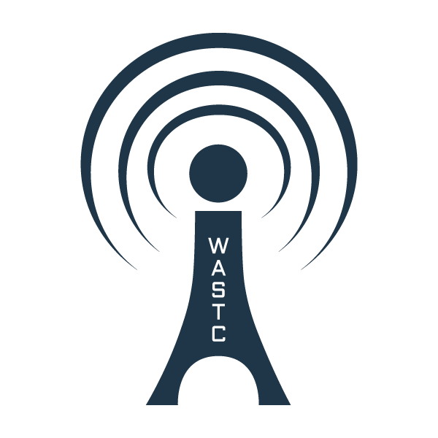

2019 WASTC Faculty Development Week
Coastline Community College

Evening Entertainment Ideas

- WASTC Networking Social Event
  - Tuesday or Wednesday [TBD] Homewood Suites, 12005 Harbor Blvd, Garden Grove
  - 5:00 – 8:00 pm, Light dinner, beer and wine
- Disneyland, 1.5 miles away [Downtown Disney, Free with lots shopping, dining and street music]
- Knotts’ Berry Farm, 8 miles away
- Outlets of Orange
- Angel Stadium
- Huntington Beach
- Newport Beach

