College Logo Goes Here

The 1st annual <College> - All Academy Day Competition!

Date: <Date Goes Here>
Location: <Event Location Address>

Time: 9:00 am – 3:00 pm
Website: www.college.edu/cybersecurity

This all day high school IT Skills Competition has 4 main individual team components (45 minutes each) and one school component. Check with your teacher to register your team. 3 students per team, school can send multiple teams.

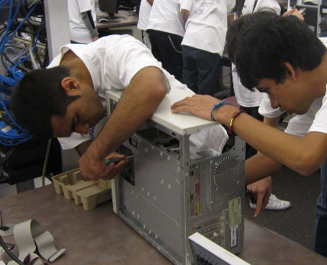
Computer Build: The judging and scoring for this component will be based on disassembly/rebuilding, problem solving, mechanics, process, team character traits, and teamwork.

Presentation: Each team will give a short presentation to the two judges who observed and scored the computer build.

Troubleshooting: This component involves troubleshooting a Packet Tracer ITE (IT Essentials) Small Office Home Office (SOHO) scenario.

Cyber Security: Download "virtual image" representations of operating systems with known flaws, or cybersecurity "vulnerabilities." Your team will need to secure the systems.

Quiz Bowl: Each school will select four students to compete in a school-versus-school Quiz Bowl.

Contact Competition Coordinator Name at email address or call ###-###-####
College Faculty at email address or call ###-###-####

