

WASTC 2018 Faculty Development Weeks

Palo Alto Networks Firewall 8.0 Essentials: Configuration and Management (EDU-210)

**Dates: In Person, June 11 - 15, 2018 Cabrillo College, Aptos CA**

**Overview**

The Palo Alto Networks Firewall 8.0 Essentials: Configuration and Management (EDU-210) course is five days of instructor-led training that will enable you to:

*  Configure and manage the essential features of Palo Alto Networks® next-generation firewalls
* Configure and manage GlobalProtect to protect systems that are located outside of the data center perimeter
* Configure and manage firewall high availability
* Monitor network traffic using the interactive web interface and firewall reports

**Palo Alto Networks Education**

Training from Palo Alto Networks® and a Palo Alto Networks® Authorized Training Center delivers the knowledge and expertise to prepare you to protect our way of life in the digital age. Our trusted security certifications give you the next-generation security platform knowledge necessary to prevent successful cyber attacks and safely enable applications.

**Course Objectives**

Successful completion of this five-day, instructor-led course will enhance the student’s understanding of how to configure and manage Palo Alto Networks® next-generation firewalls. The student will learn and get hands-on experience configuring, managing, and monitoring a firewall in a lab environment.

**Scope**

**• Course level:** Introductory

**• Course duration**: 5days

**• Course format:** Combines lecture and hands-on labs

**• Platform support:** Palo Alto Networks® next-generation enterprise firewalls running the PAN-OS® operating system

**TargetAudience**

Security Engineers, Security Administrators, Security Operations Specialists, Security Analysts, Network Engineers, and Support Staff

**Prerequisites**

Students must have a basic familiarity with networking concepts including routing, switching, and IP addressing. Students also should be familiar with basic security concepts. Experience with other security technologies (IPS, proxy, and content filtering) is a plus

Instructor: Wm. Guy Bass

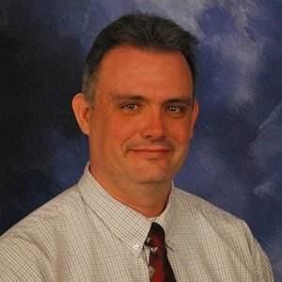

Sponsored by:

Guy is an Information Technology Specialist with over 25 years’ experience.

I have been training Information Security Specialist for over 17 years on the latest

techniques, methodologies, hardware and software used in the industry.

Currently working for Palo Alto Networks as the Academy Technical Lead. I help faculty learn to use our platforms in their classrooms.  I provide training classes for the faculty, labs for use in their classrooms, materials for the classroom and instructional design assistance.  I also work as a bridge between the academic and corporate environments.  Occasionally I am called upon to do corporate training as well.

What I enjoy most about my current employment is helping faculty grow their programs and helping them train the next generation of cyber security professionals around the world.

My biggest trait is my ability to learn systems quickly and trouble shoot problems with systems that I have little or no experience with. I am an excellent presenter, communicator, leader and team player.

